**Synopsis Of The Project**

****Online Cotton Selling Web Application****

# 1. Title of the Project

**"Online Cotton Selling Web Application"** This project focuses on developing a web-based application that facilitates direct cotton trading between sellers (cotton industries) and buyers (textile industries, wholesalers, and traders). The system eliminates middlemen, ensuring fair pricing and transparency.

# Introduction

The cotton industry relies on traditional trading methods involving multiple intermediaries, leading to price fluctuations, delays, and transparency issues. This project aims to develop an **Online Cotton Selling Web Application** to connect cotton sellers directly with buyers, ensuring fair pricing and seamless transactions.

Sellers can list their products with details like pricing and stock availability, while buyers can browse, compare, and purchase cotton in real-time. The platform will feature **real-time price updates, inventory management, order tracking, and secure payments**. Future enhancements may include **AI-based price prediction** and **international trade support**.

Built using **JSP, Servlets, JDBC, and Apache Tomcat 9.0**, this system will make cotton trading more **efficient, transparent, and profitable**.

# 3. Objective of the Project

The main objectives of this project are:

* To provide a **secure** and **user-friendly** platform for cotton industries to sell their products online.
* To enable **direct transactions** between buyers and sellers, eliminating intermediaries.
* To implement a **real-time order management system** with tracking and payment processing.
* To offer **market insights**, including real-time cotton price updates and demand analysis.
* To integrate **logistics and shipment tracking** for efficient delivery.

# 4. Input of the Project

The input data required for the system includes:

* **User Registration Data:** Name, email, contact details, company name, and authentication credentials.
* **Product Details:** Type of cotton, quality, price per unit, available stock, and images of cotton samples.
* **Order Details:** Buyer’s order quantity, selected product, delivery address, and payment details.
* **Payment Processing Data:** Transaction ID, payment gateway response, and invoice generation.

# 5. Output of the Project

The system generates the following outputs:

* **Seller Dashboard:** Displays listed products, order status, and earnings.
* **Buyer Dashboard:** Shows available cotton products, order history, and invoice details.
* **Admin Panel:** Manages users, approves product listings, and handles disputes.
* **Reports & Analytics:** Sales reports, demand trends, and pricing insights.

# Process Logic

* **Seller Dashboard**
* **Buyer Dashboard**
* **Admin**
* **Report And Analytics**
* **Registration Data**
* **Product Details**
* **Order Details**
* **Payment Processing Data**

**Process**

The project follows a structured process flow:

1. **User Registration & Authentication:** Users sign up and log in to the system.
2. **Product Listing:** Sellers add cotton products with descriptions, pricing, and stock details.
3. **Product Browsing & Ordering:** Buyers search and compare cotton types and place orders.
4. **Payment Processing:** Transactions are securely handled using Razorpay or PayPal.
5. **Order Fulfillment:** Sellers receive orders, process them, and ship the products.
6. **Delivery & Tracking:** Integrated logistics partners handle delivery, and buyers track shipments.
7. **Admin Oversight:** Admin manages user approvals, disputes, and platform analytics.

**Context Diagram**

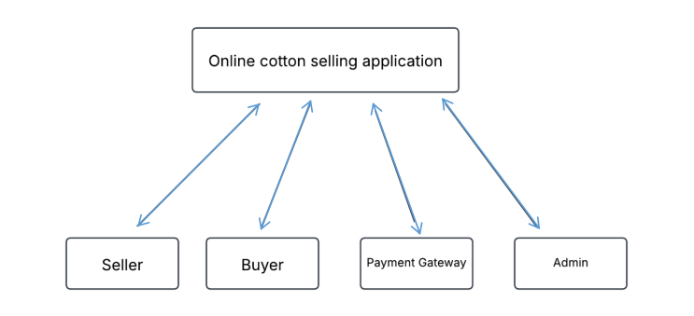

# Data Flow diagram of the project

* Level One Diagram

# online_cotton_content_diagram

# 8. Data Flow Diagram (DFD) Level Zero Diagram

# online_cotton_dfd

# 9. Entity-Relationship (ER) Diagram

(Diagram Placeholder: ER Diagram will be added here)

# 10. Requirement Tools and Platforms

## ****Hardware Requirements****

* **Processor:** Intel i5 or higher
* **RAM:** 4GB or more
* **Storage:** 20GB minimum

## ****Software Requirements****

* **Operating System:** Windows/Linux/MacOS
* **Backend:** Java (JSP, Servlets, JDBC)
* **Frontend:** HTML, CSS, JavaScript
* **Database:** MySQL
* **Web Server:** Apache Tomcat 9.0
* **Payment Gateway:** Razorpay / PayPal API

# 11. Acceptance Letter

# 12. Project Duration

The estimated duration for the completion of this project is **2 months**.

# 13. Members of the Project

This project is being developed by a single member:

* **Member:** Aditya P Singi
* **Role No :** U02BF22S0178

# 14. Limitations of the Project

Despite its advantages, the system has some limitations:

* **Internet Dependency:** The platform requires an active internet connection.
* **Limited Payment Options:** Initially, only Razorpay and PayPal are integrated.
* **Manual Approvals:** Admin intervention is required for product approvals.
* **Scalability Challenges:** May need optimization for large-scale transactions.

# 15. Scope of the Application

The Online Cotton Selling Web Application has broad applicability in the cotton industry:

* **For Cotton Producers:** Provides direct market access and better price control.
* **For Buyers (Textile Industries, Traders):** Enables easy procurement with quality assurance.
* **For Market Analysis:** Offers insights into pricing trends and demand forecasts.
* **For Future Enhancements:** Can be expanded to support international trade and AI-based price predictions.